QUESTIONNAIRE
Assistant of the Department “Agronomy, Breeding and Biotechnology”
Personal Information about the teacher
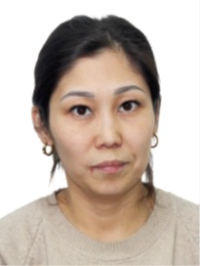 | Full Name (according to official documents) |  | NURTAYEVA ARAYLYM SOVETZHANOVNA
 | Date of Birth (day/month/year) |  | 11.12.1991 y.
 | Gender |  | Female
 | Nationality |  | Kazakh
 | Citizenship |  | Republic of Kazakhstan
 | Mobile Phone, E-mail |  | +77072970072  sovetzhanovna.arailym@kaznaru.edu.kz
Education
Higher Education Institution
а) Name |  | Almaty Technological University
б) Country, City |  | Kazakhstan, Almaty
в) Years of Study (Admission–Graduation) |  | 2010-2014г.
г) Qualification awarded upon graduation |  | «Biotechnologist»
Current Place of Employment
Full name of the organization |  | Non-commercial Joint-Stock Company “Kazakh National Agrarian Research University”
Position held |  | Assistant of the Department of “Agronomy, Breeding and Biotechnology”, Master’s degree holder

Academic Degree
Degree | Quantity | Year of Completion (Defense) |  | Specialty Code / Program
Master’s Degree | 1 | 2016- 2018 |  | 7М05101– «Biotechnology» (Scientific and Pedagogical Track), 2 years
Foreign Language Proficiency
Language |  |  | Proficiency Level (basic, intermediate, advanced)
English |  |  | Pre-Intermediate

